Project Plan

With the end of sprint two on the twelve of November and discussions of Sprint Three starting to brew, the team has started to make plans on implementing the new features requested by Acme Entertainment. The Third Sprint for Rapid application development will be starting on the 19 th of November 2020, with the scrum master being Panashe Madakasi presenting the completed project for the third sprint on 26th of November 2020, all team members have been given a tasks to complete and all tasks need to completed before the deadline.

Development plan

Once again, we continue to develop the website and add on more feature that Acme Entertainment has requested, a third folder has been created in the repository to hold the reports and the updated website that adheres to the new requirements. For the third sprint the client has requested a more secure login for the database to prevent attacks on the database along with more website feature like a top ten most popular movies based on rating that will refresh automatically, a graph is also required as a quick easy way to display the top ten rated movies.

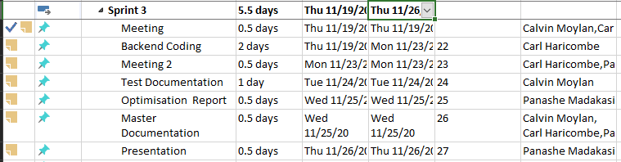

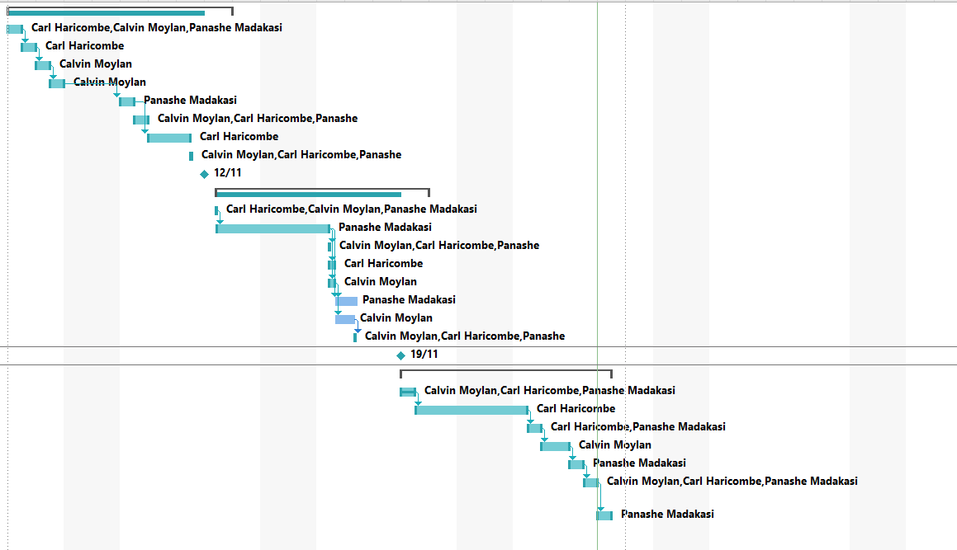

|  |
| --- |
|  |
|  |
|  |
|  |
|  |
|  |
|  |

|  |  |  |
| --- | --- | --- |
| Meetings Minutes | | |
| Call between Carl and Panashe  19/11/2020 | |  |
| Carl and Panashe  23/11/2020 | |  |
| FIN:  Panashe Madakasi  Calstar: Calvin Moylan  23/11/2020-25/11/2020 |  | |

Source Control

A Sprint three folder has been added to the repository being used on GitHub to easily distinguish the three different sprints and their files shown below, this source control helps the group organize files and code keeping the files UpToDate.

For the third sprint the repository was managed by Panashe with Carl and Calvin uploading their completed tasks to the sprint three file created.

Link: https://github.com/CalvinMoylanTAFE/RapidAppDevelopment/blob/main/Sprint%20Two/RapidAppDevelopment-main/Master%20Document%20and%20Reports/Master%20Document.docx

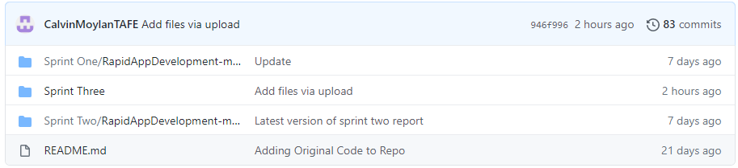

# Introduction

The client has asked us to implement new functionality for the third sprint of production. These new requests include a password system for website administrators and ACME personnel. The passwords must meet a minimum password complexity test. The users must also be able to rate the movies on the website. They also asked us to implement a live top 10 page for displaying the highest rated movies on the website which needs to automatically update.

# Scope

## Features (Movie Database website) In Scope

* Add a password system for Administrators and ACME personnel
* Passwords in the system must meet a minimum complexity
* Ability for users to rate movies
* A live automatically updates top 10 ranked movies page.

## Functional

* Admin and ACME personnel login
* Password System includes minimum complexity
* User rating movies
* Display top 10 ranked movies

## Non- functional requirements

* The Movies Rankings Database
* Admin and ACME password Database
* Rate movies page/form

# Quality Objective

* All features have been correctly implemented as per requested by the client.
* There are no bugs or errors with the production version of the website.

# Roles and Responsibilities

Panashe Madakasi (Scrum Master)

* Project management plan (sprint one)
* Master Document Sprint 2 addition
* Source control Snapshot
* Demonstration
* Optimisation Report

Carl Haricombe

* Coding (Developer)

Calvin Moylan

* Software Development Testing Plan

# Test Methodology

## RAD (Rapid application Development)

Moving on from sprint two, which required us to implement a newsletter subscription and an admin portal, we have been requested to implement a new Admin and ACME personnel password system. This will require a change to password database as well as include a minimum complexity for the password. We are also required to implement a rating system to the movies which are stored on the website. This will also require a slight change to the movies database which will now need to keep track of user ratings. Finally, we must also include a top 10 ranked movies page which will display a table of the top 10 ranked movies that automatically updates.

# Testing strategy

For the testing strategy, we have decided to use behavioral tests. This way we can test that all new functionality that we have recently implemented works as intended. This is also known as Blackbox testing since it will only focus on the front end working as intended as the users do not need to know what is happening behind the scenes.

## Quality Assurance

* Quality assurance will up to the CITE’s management standards evaluation project performance and the hand off complies with customer requirements.

# Testing Environment

|  |  |
| --- | --- |
| **OS** | **Browser** |
| Windows 10 | Chrome |

## Hardware requirements

* Windows 10 (Computer)
* Internet connection
* Peripherals such as a mouse and keyboard
* Monitor

# Test Cases

|  |  |  |  |
| --- | --- | --- | --- |
| Prototype | Proofing | Description | Result |
| Rating a movie |  | User can search for movie and give it a rating | Pass |
| Live Rating Chart |  | Users can view the highest rated movies through the live rating chart. | Pass |
| Admin and ACME Personnel Login |  | Admin and ACME Personnel login page that requires a password of minimum complexity | Pass |

Optimisation Report

Optimisation within the website is the process of using tools or strategies to improve performance, interaction or security for the website to make website fast, responsive and secure.

* Error handling

- Error handling is very important, descriptions of errors can be helpful for usability to both programmers and users, users should be able to use the website without error but if they encounter an error it should be apparent that there’s a problem with a message not to waste the users time figure out why a function isn’t working or why a site is down. Messages like error 404 page not found and a under maintenance page asking the user to come back later are standards in the industry. These pages explain there is a problem and give the user a suggestion to fix the problem.

Problems users might run into and solutions given in the website include:

* Logging into the admin page
  + Admin ID: if the user tries to type with characters that aren’t numbers
  + Suggestion given: Only input Number for ID
  + Admin password: if a password is too short
  + Suggestion given: Invalid Password too short
  + Admin Email: if an invalid email is typed
  + Suggestion given: Invalid Password too short
* Signing up for the website’s membership
  + User First Name: If the user uses numbers
  + Suggestion given: Only accepts Letters
  + User Last Name: If the user uses numbers
  + Suggestion given: Only accepts Letters
  + User Email: User types invalid email
  + Suggestion given: Invalid email

